Exercise 1:

Draw a UML diagram for hotel reservation system. In a hotel reservation system, a

customer can make online booking for a hotel, by specifying the accommodation

requirements such as type of room (AC/Non-AC, One bed/two bed), total no of rooms,

duration of stay. The system selects a suitable hotel as per customer’s requirements. If

a hotel is found then the availability of rooms in that hotel is checked. The charges are

calculated for the selected requirement and these are acknowledged to the customer. If

the customer is satisfactory about the selection made by the system, then he confirms

the reservation.

Aim:

The aim of this UML diagram is to model the structure and behavior of a Hotel Reservation System where a customer can make an online booking by specifying their accommodation requirements. The system will select a suitable hotel, check room availability, calculate charges, and allow the customer to confirm the reservation if satisfied.

Procedure:

Identify the key components:

Define the relationships:

A Customer can make a Reservation.

A Reservation is associated with a Hotel and a Room.

A Hotel contains multiple Rooms.

A Reservation involves a Payment.

Define the attributes and methods:

Customer: Attributes (name, contact details), Methods (makeReservation, confirmReservation).

Hotel: Attributes (name, location, roomList), Methods (checkAvailability).

Room: Attributes (roomType, roomNumber, isAC, numberOfBeds, price), Methods (calculateCharges).

Reservation: Attributes (reservationID, customer, hotel, room, duration, totalCharges), Methods (confirmReservation).

Payment: Attributes (paymentID, amount, paymentStatus), Methods (processPayment).

OUTPUT :

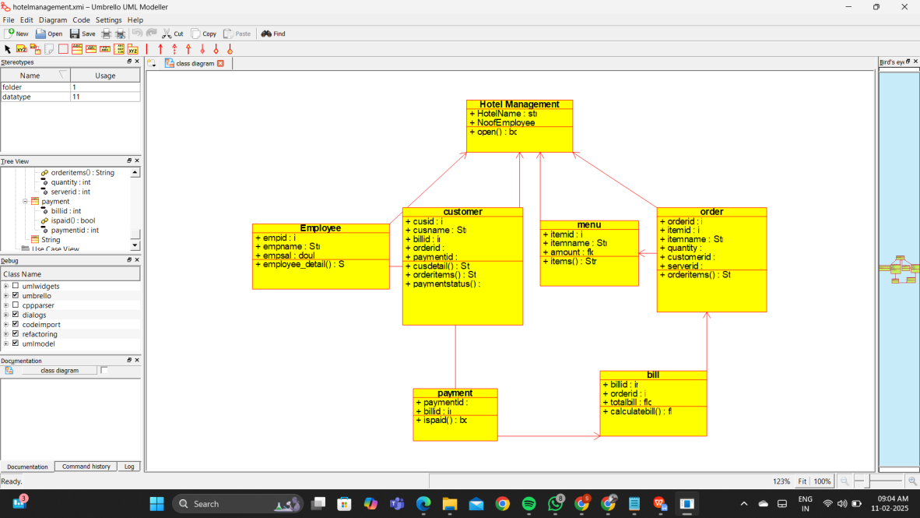

Result:

Thus the UML diagram has been implemented successfully.